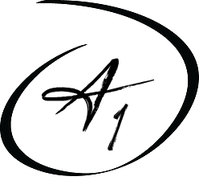
A1 Healthcare Staffing
5533 W. 109th Street, Oak Lawn, IL 60453
Phone: (708) 269-8665 Fax: (800) 730-1019
Email: a1healthstaff@gmail.com
Website: www.a1healthcarestaff.com

Comprehensive Health Statement
Name: ______________________________________________________________________
Address: ____________________________________________________________________

Physical Exam:

The above individual has been examined and found to be in good health without evidence of communicable disease and free from health conditions which would be of potential risk to the patient or which might interfere with the performance of the person’s duties as a health care worker.

Physician or Nurse Practitioner:
Name: ____________________________________ Phone Number: ____________________
Address:_____________________________________________________________________
Signature: :______________________________________________Date: ________________

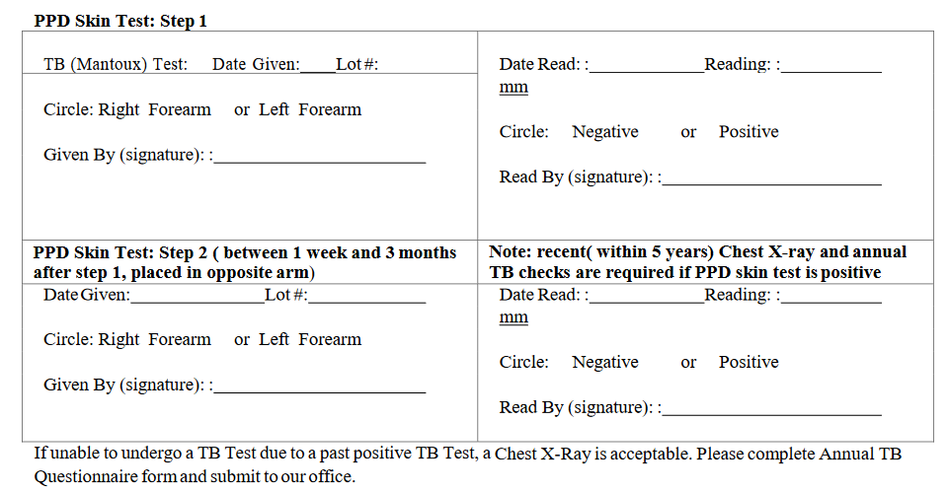

Date: ___________________________ Chest X-Ray Results: __________________________
Please attach radiological report.

